Fitness Tracker Enhanced

Patrick Quagge

CST-451 Capstone Project Proposal

Grand Canyon University

Instructor: Professor Michael Landreth

Revision: 3

Date: 3/14/2024

**ABSTRACT**

The purpose of this document is to go over the proposal for the Fitness Tracker Enhanced Project. The focus of this application is to provide users with a simple to use Fitness Tracker that has Enhanced user interface functionality. The Enhancements will come with an upgraded workout list, new buttons and possibly animations for each of the workouts entered. Other possible enhancements may be a goal tracker for users to enter goals and keep track of when they complete them with rewards for completing their goal.

|  |
| --- |
| History and Signoff Sheet |

**Change Record**

|  |  |  |
| --- | --- | --- |
| **Date** | **Author** | **Revision Notes** |
| 2/1/2024 | Patrick Quagge | Initial draft for review/discussion |
| 2/15/2024 | Patrick Quagge | Updated Scripture Passages, corrected spelling mistakes, noted UML attachment in document package,UML Overall Picture Updated ERD updated, planned changes updated |
| 3/14/2024 | Patrick Quagge | Through second phase of development Enhancements instituted: Goal list, Animations |

|  |
| --- |
| **Overall Instructor Feedback/Comments** |

|  |
| --- |
| **Overall Instructor Feedback/Comments** |

**Integrated Instructor Feedback into Project Documentation**

Yes  No

**Project Approval**

Professor Donna Jackson

**TABLE OF CONTENTS**

Project Overview and Project Objectives 4

Project Scope 5

Project Success Measures 6

Project High-Level Solution 7

Project Controls 8

Project Cost and Schedule 10

Appendix A – References 11

Appendix B – Copyright Compliance 12

Project Overview and Project Objectives

**State the Problem and Background**

This project is being undertaken as Health and Fitness is a large part of my life. I believe it is crucial to the success I have experienced in my life. I am a large proprietor of Strong Body, Strong Mind. I have come across many people that want to implement fitness into their life, but they fail. The idea of this application is to create a simple to use application for users of every fitness level to help them track their progress and keep them on track for their fitness goals. Sometimes a simple visual representation can go a long way.

**Christian Worldview**

Though it is not talked a lot in the Christian texts about fitness I did find passage that goes over some of the principles that my proposal speaks about above:

God says to discipline your body 1 Corinthians 9:24-27

1 Corinthians 6:19-20 (KJV) What? know ye not that your body is the temple of the Holy Ghost, which is in you, which ye have of God, and ye are not your own?)

As seen in this Christian text it says to discipline your body, which is the goal of this application. To help people reach a level of discipline in their body to achieve a better life. For that is one of the things that has stood out to me about the Christian Faith, to help people, without wanting in return.

**Project Objectives**

Below shows the major milestones of this application. Each of these milestones will have smaller objectives within them that follow the Agile methodology. Each small objective will lead to completion of the following milestones:

* **Initial Proposal complete**
* **Requirements discerned.**
* **Architectural Plan for App completed**
* **Base code developed and tested**
* **Institution of Enhancements to Application**
* **Fine tuning of application**
* **Application completion**

**Challenges**

Current challenges that may occur with the application are to follow:

* Database connection:
  + In the past the JavaScript application that was this applications predecessor had issues connecting fully to the database though it was tested with Postman and all API entry points functioned as intended.
    - A standalone version of the application can be built to negate this, if this occurs the problem cannot be solved.
      * Final iteration: This challenge was realized and work around enabled. Application is fully hybrid with user data being secured through database and front end React server handing workout data.
* Scope:
  + Staying in scope is a challenge for this application. Though large enhancements to the new fitness tracker are wanted it is important to keep time and overall functionality in mind. Making sure that the project’s main goals are completed is the prime directive of this project.
    - Final iteration: Development team successfully executed all core functionality and as many Enhancements as possible within project completion time limit. Team successfully avoided scope creep throughout project.

**Benefits and Opportunities**

Benefits or opportunities of this project are that it can give me the opportunity to create a simple but effective application that can help people with their goals. While at the same time focusing on the front-end user interface functionality that I wish to grow my skills in currently.

Project Scope

The scope of this proposed project is to provide a simple to use and functional fitness tracker for the everyday person. Though an engaging UI is the focus for this application it is important that the enhanced user experience does not go too far. Though it should be engaging with the limited development time the core functionality is the most important aspect.

|  |  |  |
| --- | --- | --- |
| Stakeholder Name | Role(s) | Responsibilities |
| Patrick Quagge | Developer | All |
|  |  |  |

|  |  |  |  |  |  |  |  |  |  |  |
| --- | --- | --- | --- | --- | --- | --- | --- | --- | --- | --- |
| Work Breakdown Structure | | | | | | | | | | |
| ID | Task | Dependencies | Status | Effort Hours | Cost | Start Date | Planned Completion | Estimate to Completion | Actual Completion | Resource |
| 1 | Proposal |  | Complete | 2+ | 0.00 | 2/1/2024 | 2/4/2024 | 2/3/2024 | 2/3/2024 |  |
| 2 | Requirements |  | Complete | 4+ | 0.00 | 2/5/2024 | 2/11/2024 | 2/11/2024 | 2/11/2024 |  |
| 3 | Architectural Plan |  | Complete | 6+ | 0.00 | 2/12/2024 | 2/18/2024 | 2/18/2024 | 2/18/2024 |  |
| 4 | Base Code |  | Complete | 20+ | 0.00 | 2/19/2024 | 2/25/2024 | 2/25/2024 | 2/25/2024 | Visual Studio Code |
| 5 | Institute Enhancements |  | Complete | 16+ | 0.00 | 2/26/2024 | 3/3/2024 | 3/3/2024 | 3/3/2024 | Visual Studio Code |
| 6 | Fine Tune Application |  | Complete | 10+ | 0.00 | 3/4/2024 | 3/11/2024 | 3/11/2024 | 3/11/2024 | Visual Studio Code |
| 7 | Application Completion |  | Complete | 10+ | 0.00 | 3/12/2024 | 3/17/2024 | 3/17/2024 | 3/17/2024 | Visual Studio Code |
| 8 | Project Wrap up |  | In work | 8+ | 0.00 | 3/18/2024 | 3/24/2024 | 3/24/2024 | 3/24/2024 |  |

Project Success Measures

|  |
| --- |
| Project Completion Criteria |
| 1 – Functioning application |
| 2 – Enhanced User Experience |
|  |

|  |  |  |  |  |  |
| --- | --- | --- | --- | --- | --- |
| Assumptions and Constraints | | | | | |
| ID | Description | Comments | Type | Status | Date Entered |
| 1 | Base code functionality  Enhancements | It is assumed that the base code is going to run as intended. If the back end successfully runs, then the likely hood of the res of the application working will high  It is assumed that the enhancements to the front end will run as intended. This will provide a engaging user experience that will still be simple to use | Assumption | Complete | 2/1/2024 |
| 2 | Full Database Connection  Keeping enhancements in scope | As stated before in this proposal the predecessor to this application had issues fully connecting to the database. Steps can be taken to demonstrate that the functionality of the application works by making it a standalone React application. Though database connectivity is preferred it is not a hard requirement to show success  Though enhancements to the UI are the goal the team will want to make sure that the UI enhancements will not be overarching and consume to much of the project timeline. Simple but elegant is the goal here. | Constraint | Complete | 2/1/2024 |

Project High-Level Solution

**Introduction**

At this time there are no major challenges of the project that have not been listed above. The main topic of this project is to provide a simple to use Fitness Tracker that has engaging front end user interface controls. Through this application it can be deduced that it will entice people to stay on their fitness journey and reach their goals.

**Solution**

The solution for the forementioned application will be achieved through the technical application of JavaScript code that has an express back end with a React front end. The back end will control the routes for data transfer as well as the main data points that the application will keep track of. This can be seen in the UML to follow:

Full UML will be attached in the document package.

From here the Front end of the application will be built that will have the ability for the user to Register, Login, enter workouts, edit workouts, update workouts, and delete workouts. Next the UI will be enhanced to add engaging user experiences so that it will make them want to come back and continue using the application for their fitness journey. It will be similar to the example given here:

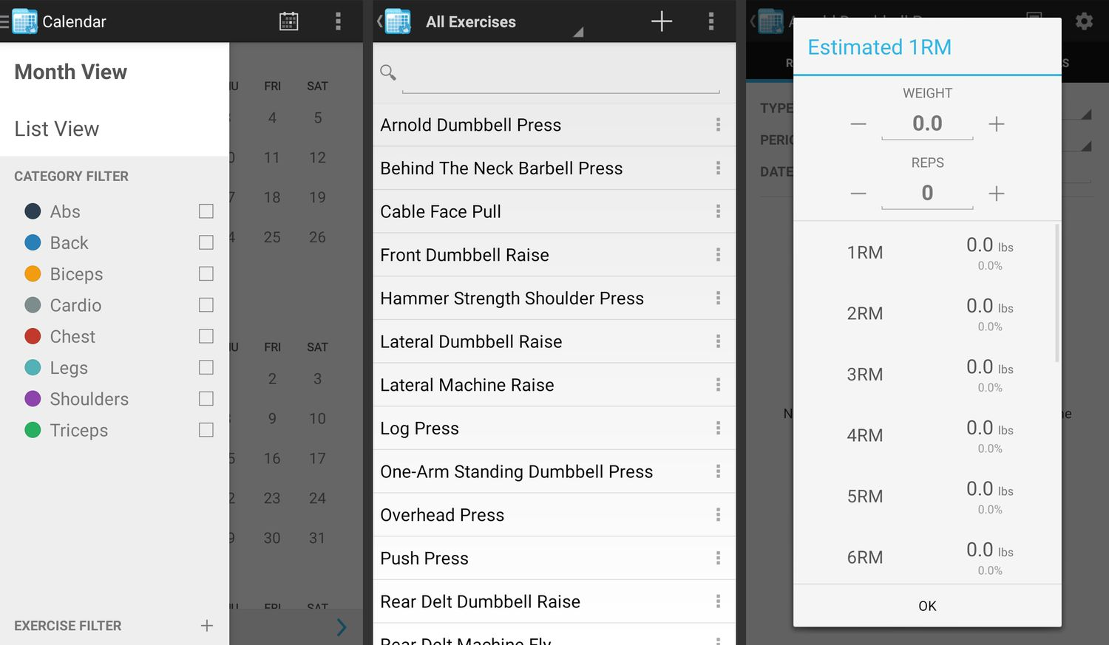

Tschabitscher(2024)

Data of said workouts will ideally be stored in a SQL database that will hold the workouts entered by the users ERD to follow:

As mentioned in this document, if database connection is an issue with this application, a standalone version will be created to demonstrate the functionality of the application.

Project Controls

1. The only current possible Risk is Database connection. Again, if this happens it can be worked around.

|  |  |  |  |  |
| --- | --- | --- | --- | --- |
| Risk Management | | | | |
|  | **Risk Probability** | **Risk Impact** |  |  |
| **Event Risk** | **(high, medium, low)** | **Risk Mitigation** | **Contingency Plan** |
| Database connection error | medium | The impact of this is that if the database does not connect the application will not update the workouts. | Ensure that database connection is complete before going to far with the application | What can be done to minimize this is to build a standalone version of the application as mentioned above. |
|  |  |  |  |  |
|  |  |  |  |  |

|  |  |  |  |  |  |  |  |  |
| --- | --- | --- | --- | --- | --- | --- | --- | --- |
| Issues Log | | | | | | | | |
| **ID** | **Description** | **Project Impact** | **Action Plan/Resolution** | **Owner** | **Importance** | **Date Entered** | **Date to Review** | **Date Resolved** |
| 1 | What is the issue? | How will this impact scope, schedule & cost? | How do you intend to deal with this issue? | Who manages this issue? |  |  |  |  |
| 2 | Database will not connect with workout/goal data | This did not affect schedule and cost as work around is planned | To deal with this work around was enacted hybridizing the application | Patrick Quagge | High | 2/12/2024 | 2/12/2024 | 2/18/2024 |
| 3 |  |  |  |  |  |  |  |  |

Possible Planned Changes:

|  |  |  |  |  |  |  |  |  |  |  |
| --- | --- | --- | --- | --- | --- | --- | --- | --- | --- | --- |
| Change Control Log | | | | | | | | | | |
| **ID** | **Change Description** | **Priority** | **Originator** | **Date Entered** | **Date Assigned** | **Evaluator** | **Status** | **Date of Decision** | **Included in Rev. #** |
| 1 | Standalone Version | 1 | Patrick Quagge | 2/4/2024 | TBD | Patrick Quagge | Not Started | TBD | 1 |
| 2 | Automatic goal updates | 3 | Patrick Quagge | 2/17/2024 | TBD | Patrick Quagge | Not Started | TBD | 2 |
| 2 | Goals List | 1 | Patrick Quagge | 2/26/2024 | 2/26/2024 | Patrick Quagge | Complete | 3/3/2024 | 2 |
| 3 | Animations | 2 | Patrick Quagge | 3/4/2024 | 3/4/2024 | Patrick Quagge | Complete | 3/10/2024 | 2 |

|  |  |  |  |
| --- | --- | --- | --- |
| Roles and Responsibilities | | | |
| Name | Team | Project Role | Responsibility |
| Patrick Quagge | Dev | Primary | Responsible for the Build and test of the application |
|  |  |  |  |

Project Cost and Schedule

1. Cost
   1. There is not cost for this project as I am building it myself.
2. Schedule
   1. Proposal
   2. Requirements Defined
   3. Architectural Plan for App completed
   4. Base code Developed.
      1. User Registration
      2. User Login
      3. Home Page
      4. Workout list
      5. Update workout
      6. Delete workout
      7. Database connection
   5. Institute Enhancements to Application
      1. Containers/Card for entered workouts
      2. Animations
      3. Goal setting
      4. Goal completion rewards
   6. Fine tune Application
      1. Smooth out any issue
   7. Application completion
      1. Finalize application
   8. Project wrap up.

Proposed Programming Schedule. This may change

|  |  |  |  |  |  |  |  |  |  |
| --- | --- | --- | --- | --- | --- | --- | --- | --- | --- |
| ID | Task | Dependencies | Status | Effort Hours  (Estimates) | Start Date | Planned Completion | Estimate to Completion | Actual Completion | Resource |
| 1 | Base Code |  | Complete | 20+ | 2/19/2024 | 2/25/2024 | 2/25/2024 | 2/25/2024 | Visual Studio Code |
| 1.1 | Register, Login, Create, Update, Delete Backend |  | Complete | 12+ | 2/19/2024 | 2/25/2024 | 2/25/2024 | 2/25/2024 | Visual Studio Code |
| 1.2 | Fronte end code Home page, Workout list, Create workout Update Workout, Delete Workout, |  | Complete | 12+ | 2/19/2024 | 2/25/2024 | 2/25/2024 | 2/25/2024 | Visual Studio Code |
| 2 | Institute Enhancements |  | Complete | 16+ | 2/26/2024 | 3/3/2024 | 3/3/2024 | 3/3/2024 | Visual Studio Code |
| 2.1 | Cards, Containers, Goals, Goal completion, Animations |  | Complete | 16+ | 2/26/2024 | 3/3/2024 | 3/3/2024 | 3/3/2024 | Visual Studio Code |
| 3 | Fine Tune Application |  | Complete | 10+ | 3/4/2024 | 3/11/2024 | 3/11/2024 | 3/11/2024 | Visual Studio Code |
| 3.1 | Resolve any bugs |  | Complete | 10+ | 3/4/2024 | 3/11/2024 | 3/11/2024 | 3/11/2024 | Visual Studio Code |

Appendix A – References

Tschabitscher, H (2024 Jan 1) *“The 10 Best Workout Log Apps of 2024”* <https://www.lifewire.com/best-workout-log-apps-4140222>

Appendix B – Copyright Compliance

For each external technical tool or code used, provide a reference to its copyright policy, clearly showing your right to use it. For each external technical tool or code used, detail how you used it, how you adapted it, how you modified it (if permitted), and why did you use it as opposed to write your own. Only a small portion of your project may rely on external code. When code libraries/packages are used, explain why this was necessary/required/recommended. Seek instructor approval for using external resources prior to beginning to work on the project.